CS 340 Project Two README
Michael Rodman
June 2026
About the Project
Grazioso Salvare Rescue Animal Dashboard
This project is an interactive web application dashboard created for Grazioso Salvare. The dashboard connects to the Austin Animal Center animal shelter database stored in MongoDB and allows the user to filter shelter animal records based on the rescue dog profiles requested by the client.
The project builds on the reusable CRUD Python module created in Project One. The dashboard imports the AnimalShelter class from CRUD_Python_Module.py and uses the module’s read() method to retrieve data from the MongoDB aac database and animals collection. The retrieved data is then displayed through a Dash web application.
The completed dashboard includes the Grazioso Salvare logo, a unique creator identifier, interactive rescue filter options, an interactive data table, a pie chart, and a geolocation chart. The dashboard allows the user to filter the data by Water Rescue, Mountain or Wilderness Rescue, Disaster or Individual Tracking, and Reset.
Motivation
This project was created to help Grazioso Salvare identify dogs that may be good candidates for search-and-rescue training. The client needed a user-friendly dashboard that could interact with the shelter database and quickly display dogs matching specific rescue profiles.
A dashboard is useful for this project because it allows nontechnical users to interact with the database without writing MongoDB queries manually. Instead of requiring users to search the database directly, the application provides radio button filters that update the table and charts automatically.
The dashboard also supports the client’s need for visual analysis. The interactive table displays detailed animal records, the pie chart summarizes the breed distribution in the current filter results, and the geolocation chart shows the selected animal’s location. Together, these features make the data easier to understand and use when identifying potential rescue candidates.
Getting Started
To get started, the Austin Animal Center shelter outcomes data set must be available in MongoDB. For this project, the database is named aac, and the collection is named animals. The dashboard uses the same MongoDB data and CRUD Python module developed earlier in the course.
The dashboard requires a MongoDB user account named aacuser. This account is used by the Python dashboard notebook to authenticate with MongoDB and retrieve records from the animals collection.
The main dashboard file is ProjectTwoDashboard.ipynb. This notebook imports the required Python libraries, imports the AnimalShelter class from CRUD_Python_Module.py, connects to MongoDB, retrieves the animal records, and launches the Dash application.
The dashboard also uses the Grazioso Salvare Logo.png file for branding. The logo is displayed at the top of the dashboard and is linked to the client’s requested URL.
The dashboard supports the following rescue filter options:
- Water Rescue
- Mountain or Wilderness Rescue
- Disaster or Individual Tracking
- Reset
When one of these options is selected, the data table, pie chart, and geolocation chart update dynamically.
Installation
The main tools used for this project were MongoDB, Python, PyMongo, Pandas, Dash, Plotly Express, Dash Leaflet, JupyterLab, and Codio.
MongoDB was used because the animal shelter data is stored in a NoSQL database. MongoDB works well for this project because each animal record can be stored as a flexible document with fields such as animal type, breed, sex, age, outcome type, latitude, and longitude.
Python was used to connect the dashboard to the database and control the dashboard logic. PyMongo was used because it allows Python code to connect to MongoDB and run database queries. Pandas was used to convert MongoDB query results into DataFrames so that the data could be displayed and processed more easily.
Dash was used to create the web application dashboard. Dash provides the layout components and callback structure needed to connect user input to dashboard output. Plotly Express was used to create the pie chart, and Dash Leaflet was used to create the geolocation chart.
This project was completed in the Codio virtual lab environment using Python 3, MongoDB Server version 7.0.21, and MongoDB Shell version 2.5.3. To reproduce the project, the user needs access to:
- Python 3
- MongoDB version 7.0.21
- PyMongo
- Pandas
- Dash
- Jupyter Dash
- Plotly Express
- Dash Leaflet
- JupyterLab
- The aac database
- The animals collection
- The aacuser MongoDB account
- ProjectTwoDashboard.ipynb
- CRUD_Python_Module.py
- Grazioso Salvare Logo.png
Usage
The dashboard is run from the ProjectTwoDashboard.ipynb notebook in JupyterLab. The notebook imports the CRUD module and creates an instance of the AnimalShelter class using the aacuser username and password.
The dashboard initially loads all records from the animals collection by calling the read() method with an empty query. The MongoDB _id field is removed from the DataFrame before the data is displayed because the Dash DataTable does not handle the MongoDB ObjectId field well.
After the dashboard loads, the user can select one of the rescue filter options. The selected filter triggers a Dash callback that runs the appropriate MongoDB query through the CRUD Python module. The returned data updates the interactive data table. The pie chart and geolocation chart then update based on the currently displayed table data.
The Water Rescue filter returns dogs that match the preferred breeds, sex, and age range for water rescue. The Mountain or Wilderness Rescue filter returns dogs that match the preferred profile for mountain or wilderness rescue. The Disaster or Individual Tracking filter returns dogs that match the preferred profile for disaster rescue or tracking work. The Reset filter returns the dashboard to the original unfiltered data set.

Code Example
The dashboard imports and instantiates the CRUD Python module as shown below:
from CRUD_Python_Module import AnimalShelter

username = "aacuser"
password = "aacuser"

db = AnimalShelter(username, password)
The dashboard retrieves all records from MongoDB for the starting dashboard state:
df = pd.DataFrame.from_records(db.read({}))

if "_id" in df.columns:
df.drop(columns=["_id"], inplace=True)
The rescue filters use MongoDB query dictionaries. For example, the Water Rescue filter uses a query similar to the following:
query = {
"animal_type": "Dog",
"breed": {
"$in": [
"Labrador Retriever Mix",
"Chesapeake Bay Retriever",
"Newfoundland"
]
},
"sex_upon_outcome": "Intact Female",
"age_upon_outcome_in_weeks": {
"$gte": 26,
"$lte": 156
}
}
The query results are converted into a DataFrame and returned to the Dash DataTable:
dff = pd.DataFrame.from_records(db.read(query))

if "_id" in dff.columns:
dff.drop(columns=["_id"], inplace=True)

return dff.to_dict("records")
Tests
The dashboard was tested in JupyterLab by running ProjectTwoDashboard.ipynb and opening the Dash application. The first test confirmed that the dashboard loaded successfully with the Grazioso Salvare logo, the creator identifier, the interactive filter options, the data table, the pie chart, and the geolocation chart.
The Reset option was tested to confirm that the full unfiltered data set displayed correctly. The Water Rescue filter was tested to confirm that the table updated to show only matching water rescue candidates. The Mountain or Wilderness Rescue filter was tested to confirm that the table updated to show only matching mountain or wilderness rescue candidates. The Disaster or Individual Tracking filter was tested to confirm that the table updated to show only matching disaster or tracking candidates.
For each filter test, the data table rows changed, the pie chart updated to show the breed distribution for the current results, and the geolocation chart continued to display a marker for the selected animal record. This confirmed that the dashboard callbacks were working and that the widgets were dynamically responding to user input.
Screenshots
The following screenshots demonstrate the completed dashboard functionality.

Starting Dashboard State
Figure 1: The starting dashboard state displays the Grazioso Salvare logo, the creator identifier, the interactive filter options, the unfiltered data table, the pie chart, and the geolocation chart.
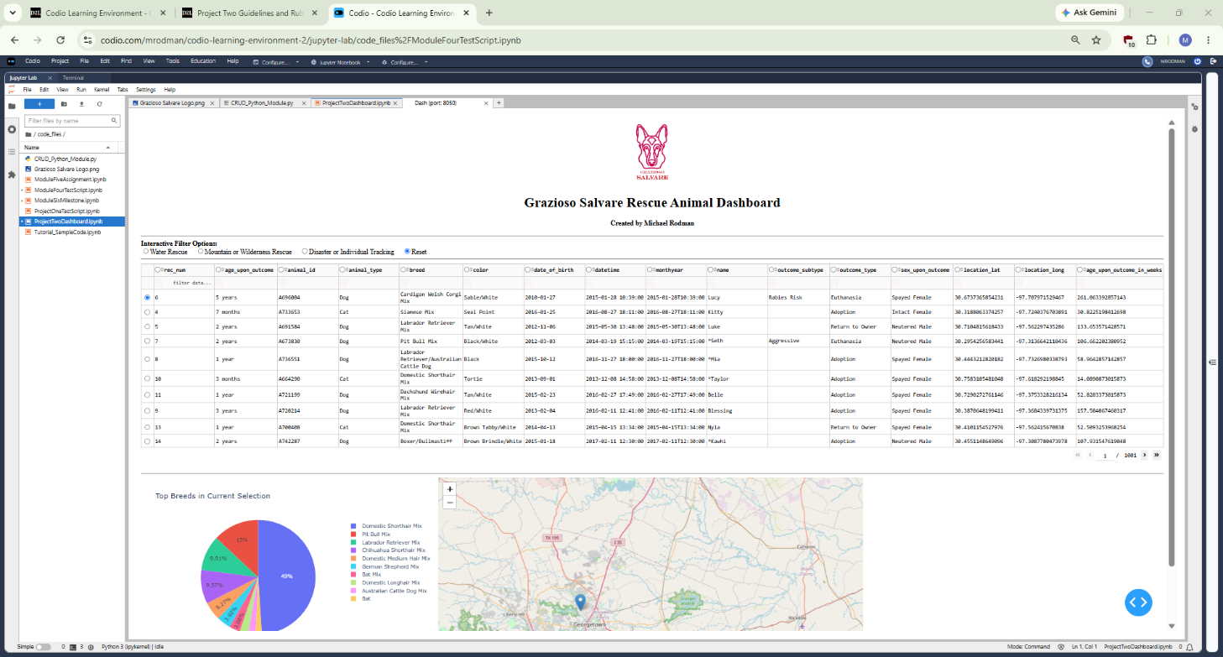
Water Rescue Filter
Figure 2: The Water Rescue filter is selected. The table, pie chart, and geolocation chart update to show dogs matching the Water Rescue profile.
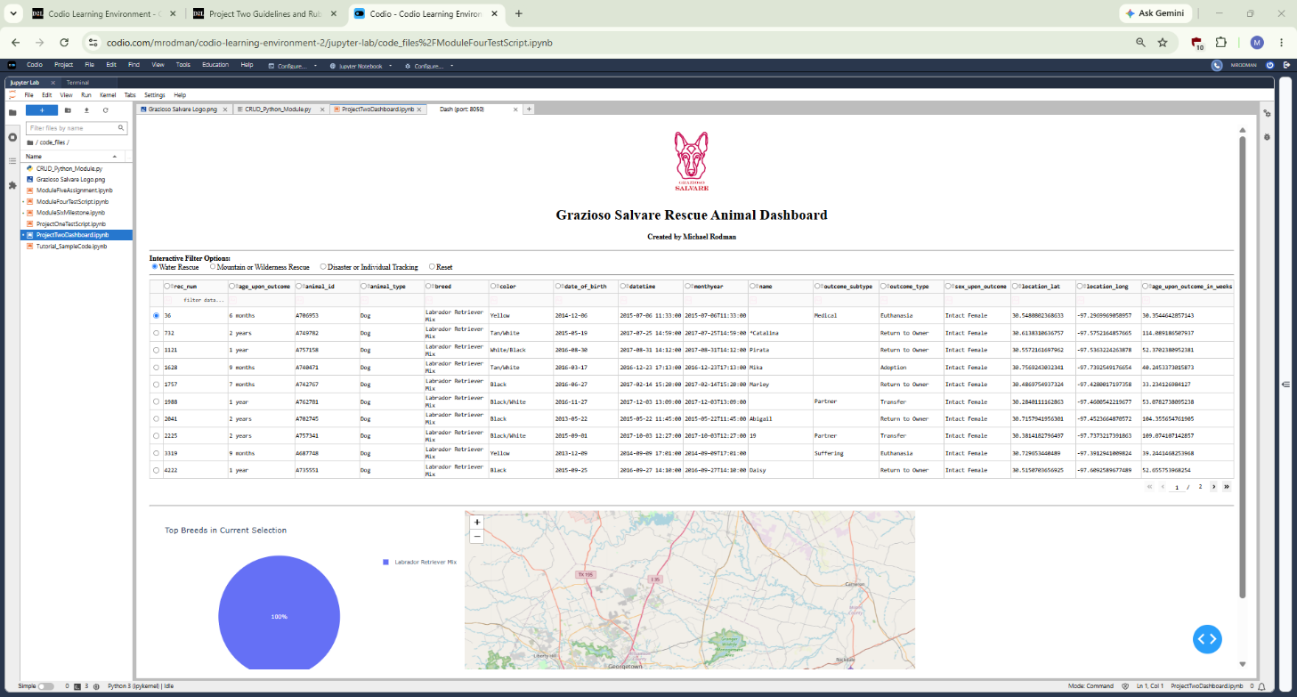
Mountain or Wilderness Rescue Filter
Figure 3: The Mountain or Wilderness Rescue filter is selected. The table, pie chart, and geolocation chart update to show dogs matching the Mountain or Wilderness Rescue profile.
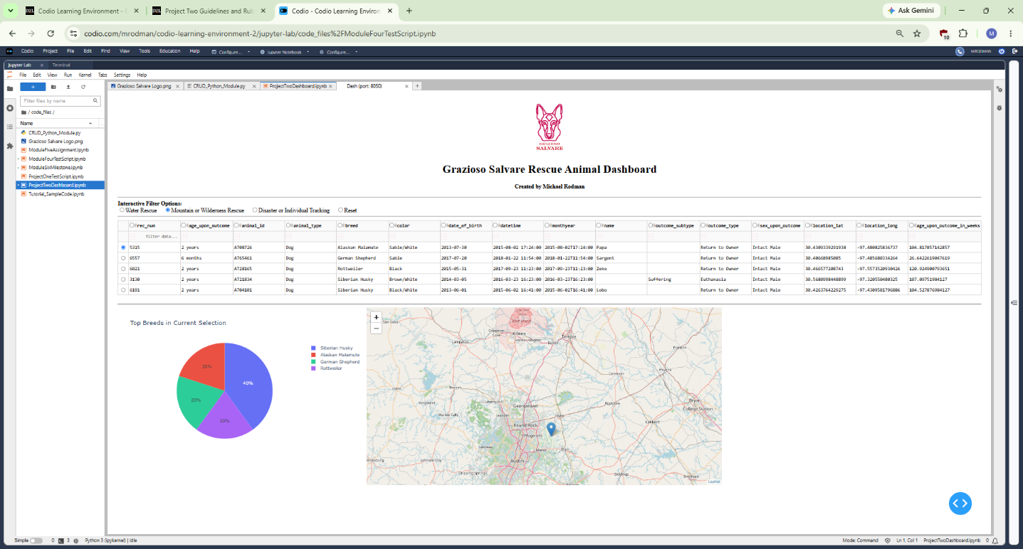
Disaster or Individual Tracking Filter
Figure 4: The Disaster or Individual Tracking filter is selected. The table, pie chart, and geolocation chart update to show dogs matching the Disaster or Individual Tracking profile.
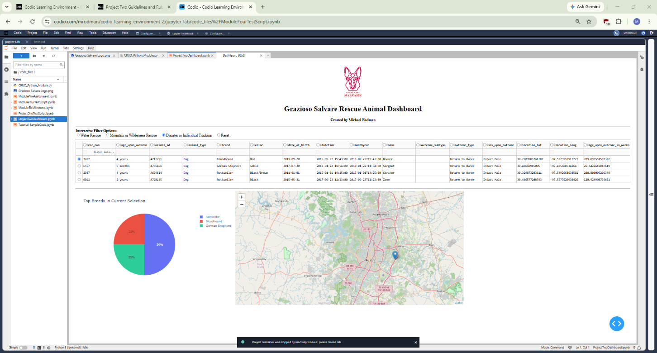
Reset Filter
Figure 5: The Reset filter is selected. The dashboard returns to the original unfiltered state.
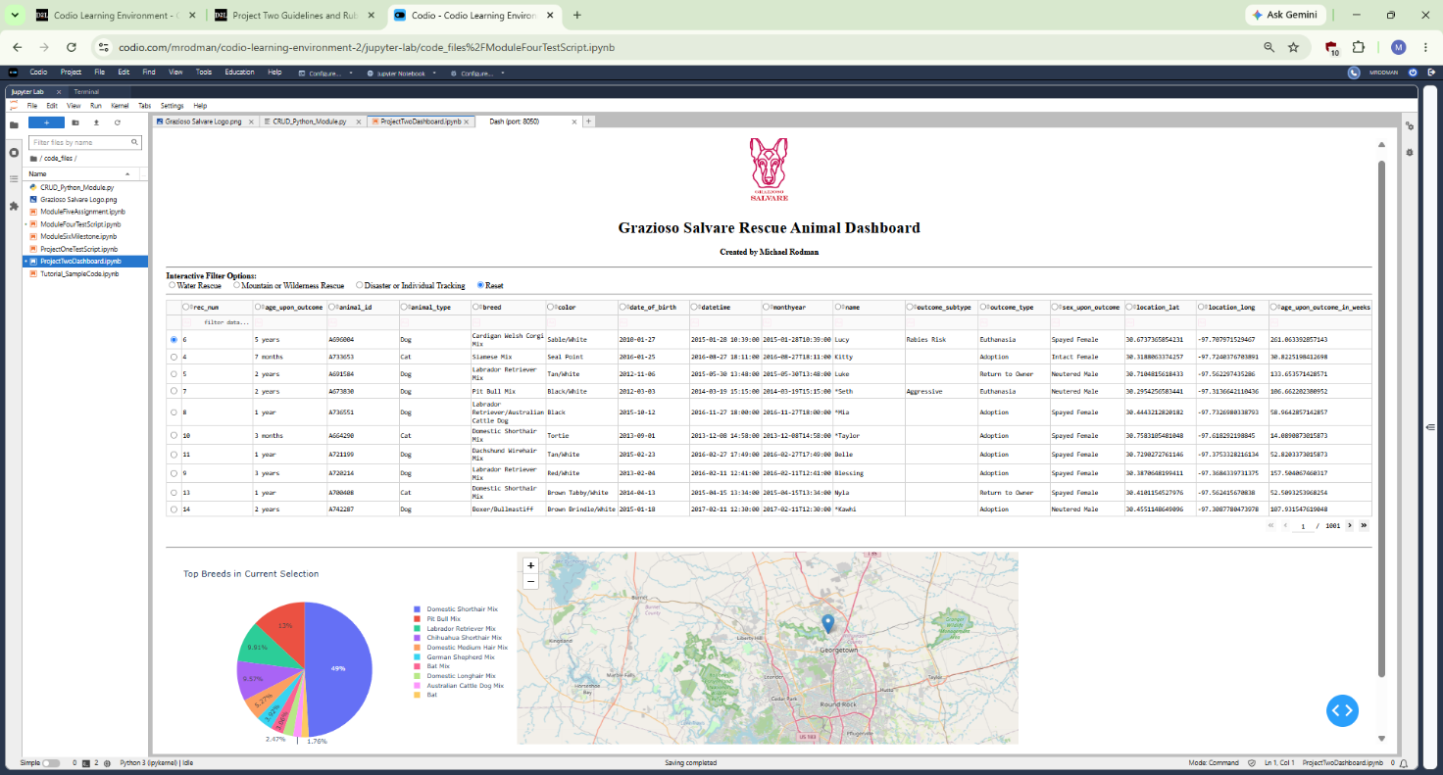

Challenges and Solutions
One challenge was making sure the dashboard imported the correct CRUD Python module. The starter notebook expected a different module name, so the import statement was updated to import AnimalShelter from CRUD_Python_Module.py.
Another challenge was confirming the correct MongoDB authentication information. The dashboard needed to use the aacuser account so that the CRUD module could connect to MongoDB and retrieve records from the aac.animals collection.
A third challenge was handling the MongoDB _id field. MongoDB returns _id as an ObjectId, which can cause display issues in the Dash DataTable. This was solved by dropping the _id column from the DataFrame before displaying the data.
Another challenge was building the rescue filters correctly. Each rescue category needed to match the client’s required animal type, breed list, sex, and age range. This was solved by writing MongoDB query dictionaries using operators such as $in, $gte, and $lte.
A final challenge was making sure all dashboard widgets updated together. This was solved by using Dash callbacks. The selected radio button updates the data table, and the filtered table data then updates the pie chart and geolocation chart.
Contact
Name: Michael Rodman
Email: rodman.michael@gmail.com

